**Kernel Panic Error Resolution of initramfs image is missing or corrupted in RHEL 7/8**

**Step1:**

Identify the reason behind Kernel Panic Error for examples:

1. New Kernel Corrupted initramfs,

2. New Packages after Patching,

3. Hardware change etc.

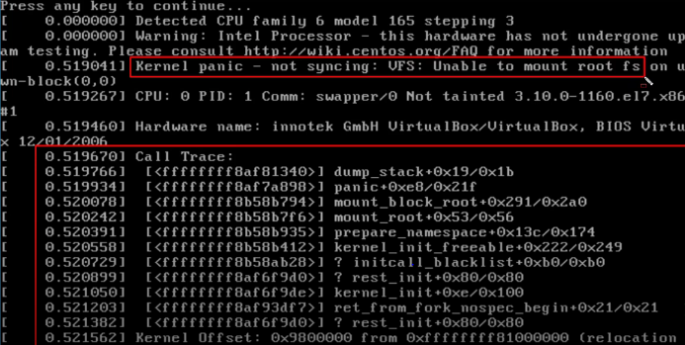

Press **Enter** or any key

**Step2:**

Below are the two examples we have taken.

1. If it is due to new kernel, then downgrade it.

2. If it is due to corrupted or missing initramfs, regenerate it.

**Step3:**

For kernel panic reboot the server and select rescue mode and we can access the server.

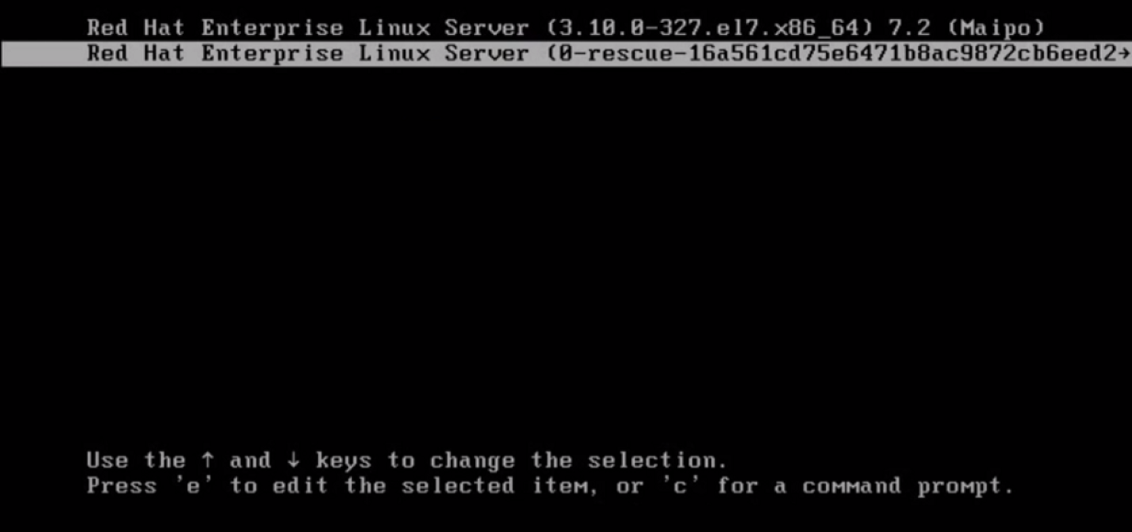

**Note:-** In RHEL 6 or earlier versions, we do not have this option, but in RHEL 7 and onwards, we have a built-in rescue image.

**Step4:**

In our case it is due to corrupted/absent initramfs file. First check your kernel version after logging into server by rescue mode.

# uname -r



**Step5:**

Now regenerate initramfs with dracut or mkinitrd command: (here your kernel version should be same as in previous command result)

**To create new initramfs use:**

# dracut initramfs-<kernel-version>.img <kernel-version>

# dracut initramfs-3.10.0-1160.el7.x86_64.img 3.10.0-1160.el7.x86_64



OR

# mkinitrd initramfs-3.10.0-1160.el7.x86_64.img 3.10.0-1160.el7.x86_64

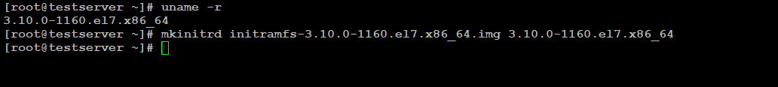

**To replace existing initramfs file use:**

# dracut -f initramfs-3.10.0-1160.el7.x86_64.img 3.10.0-1160.el7.x86_64



OR

# mkinitrd --force initramfs-3.10.0-1160.el7.x86_64.img 3.10.0-1160.el7.x86_64



**Step6:**

After replacing existing or regenerate initramfs file reboot server

# init 6



after reboot successful server up and able to login

**Step7:**

Now we are able login to the server

